Log into Tenable <https://10.1.93.10/>

use admcmitchel

Select Dashboards and Health Sherpa Dashboard (circled below)

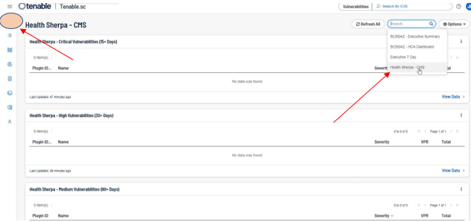

Scroll down the page to find vulnerabilities

Select View Data to expand

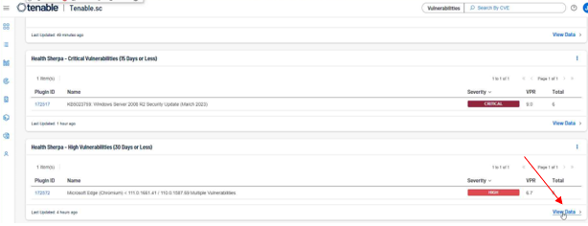

Expand by clicking on the vulnerability to show list

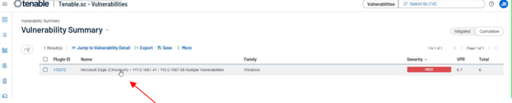

To get details on the vulnerability, select it

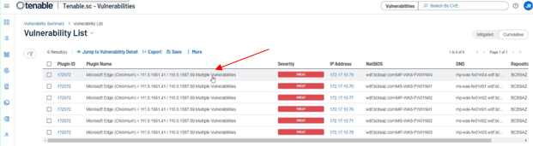

Primary information on the top right

Scroll to the bottom to find location and version numbers for applications or Windows components

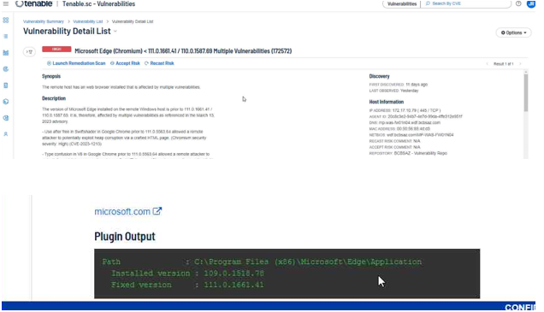

Export the list if you choose

